Deliverable 3: Probabilistic Mapping and Documentation
OSTIn project: Developing the framework
Mahmud Muhammad, Susanna Jenkins
May 27th, 2025 (this document update on July 30th, 2025)

Summary:
This report outlines the OSTIn project's framework for forecasting and updating Eruption Source Parameters (ESPs) using probabilistic methods and various data sources.
- Project Objective The project aims to develop probability density functions to describe inputs required by the NAME model at different timesteps, including location, time, plume height range, and duration. Additionally, produce python codes to visualize Name Model outputs.
- Phases One and Two Phase one involved creating Python scripts to sample key input parameters based on eruption size probabilities. Phase two focuses on automating infrasound and satellite imagery analyses to update ESP distributions. The system parses VONA messages from MAGMA and TVAAC to update ESPs in real-time. If Ash cloud provided in flight level instead of Height above ground level the Python scripts automatically convert ash cloud data from flight levels to height above ground using the SRTM dataset.
- Phase Three: Aggregate outputs from multiple NAME model runs and subsequently generate probabilistic maps and videos showing ash concentration distributions in space and time.
- The developed Python codes available via the following GitHub Link Eruption-Source-Parameters/PhaseThree at main · vharg/Eruption-Source-Parameters (Since the GitHub page is private, you’ll need to obtain access from Professor Susanna Jenkin to download the developed scripts).

Contents
Deliverable 3: Probabilistic Mapping and Documentation 1
Summary: 1
Introduction 2
Data Preparation: 3
3D Field Data Processing Tab 5
2D Field Data Processing Tab 6
Probability Analysis Tab 9
Media Viewer Tab 10
Training and Documentation: 13

Introduction
This project is structured into multiple phases, each building on the outputs and tools developed in the previous stages.
Phase One focused on developing deliverables for the initial timestep of the workflow. During this stage, we created a suite of Python scripts to stochastically sample key input parameters—mass eruption rate, eruption duration, plume height, and grain size distribution. These parameters were weighted by the probability of different eruption sizes (Volcanic Explosivity Index, VEI), informed by empirical data from Whelley et al. (2015).
Phase Two centered on the development of software capable of automatically launching infrasound and satellite imagery analyses, using eruption timing and location data obtained from Volcano Observatory Notices for Aviation (VONAs). This software also updates eruption source parameter distributions based on outputs from infrasound and satellite imagery analysis as well as subsequent VONA updates.
Phase Three, detailed in this report, involved the development of Python-based tools to:
- Aggregate outputs from multiple runs of the NAME (Numerical Atmospheric-dispersion Modelling Environment) volcanic ash dispersion model.
- Generate probabilistic maps and animations showing spatiotemporal ash concentration distributions.
The outputs of the NAME model consist of tens to hundreds of text files per simulation, depending on the number of runs and scenarios. These outputs are divided into two primary categories:
- 3D field data, which provide ash concentration at multiple altitudes for each pixel (latitude, longitude), with ash concentration (for various altitude levels) as a third dimension and time as a fourth when aggregated across simulation timesteps.
- 2D field data, where each pixel represents ground-level ash deposition. When aggregated over time, a third temporal dimension is introduced.
These data products are of critical importance to aviation hazard assessment, as they provide detailed insights into ash distribution at various altitudes over time.
As part of Phase Three, we have also developed a user-friendly Python-based dashboard application. This dashboard enables users to:
- Visualize both 3D and 2D NAME model outputs.
- Produce high-quality, publication-ready static maps and animations.
- Generate probabilistic maps and customize ash concentration thresholds to support decision-making.
The dashboard is designed for flexibility and can be deployed on local machines, in the cloud, or as a publicly accessible web application.
The following sections of this report provide a detailed walkthrough of the dashboard interface, including data preparation, visualization workflows, and the generation and interpretation of probabilistic outputs.

Data Preparation:
This step involves converting a collection of NAME model output text files—ranging from tens to hundreds into standardized NetCDF format. NetCDF (Network Common Data Form) is a widely used file format for storing array-oriented scientific data, particularly in the atmospheric, oceanographic, and geospatial domains. It allows for efficient storage, access, and sharing of large, multi-dimensional datasets (e.g., latitude, longitude, altitude, and ash concentration), making it ideal for handling volcanic ash dispersion outputs.
To begin the conversion process, all output text files must be organized and compressed into a single ZIP archive. The user then uploads this archive to the ZIP Processor module (Figure 1). The processing algorithm automatically extracts the text files, converts them into NetCDF format, and categorizes the resulting files into separate directories for 2D and 3D data fields. These standardized outputs can then be seamlessly integrated into the visualization workflow to generate publication-quality static maps and animations.
The ZIP Processor is accompanied by a user-friendly interface with the following steps:
- 🗂️ Step 1 (Optional): Upload your own NAME model simulation output in .ZIP format. If no file is provided, the system defaults to using a preloaded dataset from the Taal Volcano simulation.
- ▶️ Step 2 (Required): Click Process ZIP to begin processing either your uploaded file or the default dataset.
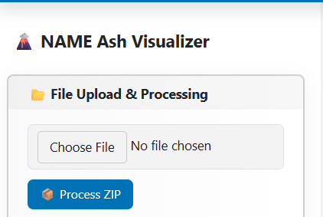
- 📥 Step 3 (Optional): Click Download Plots and Data to export a sample ZIP structure along with visualizations and NetCDF outputs from the Taal Volcano simulation.
Figure 1. Screenshot of Zip Processer Module
Visual Workflow:
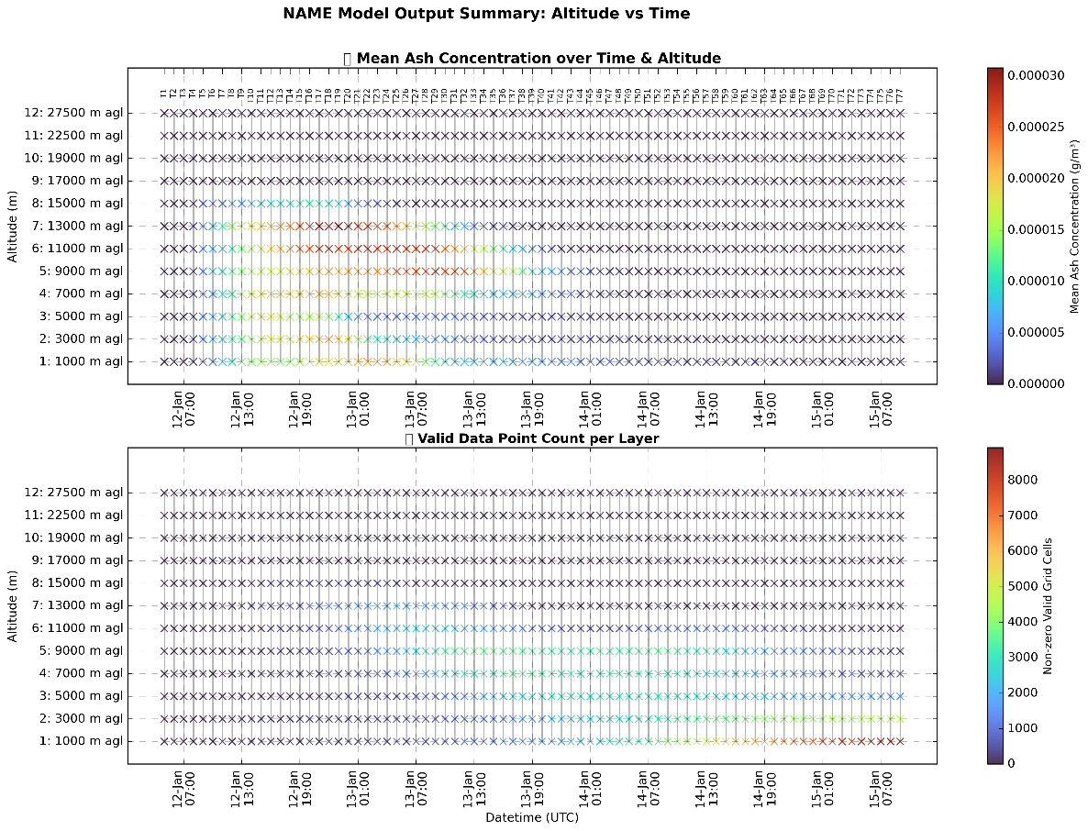
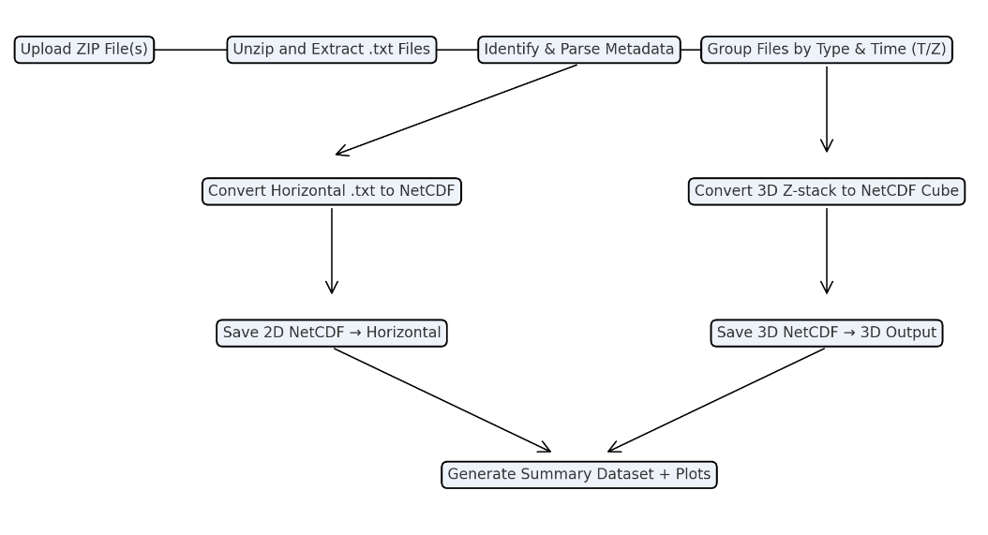
The following diagram illustrates the workflow implemented by the “NAMEDataProcessor “class. It automates the ingestion and transformation of raw `.txt` files contained in a ZIP archive into structured NetCDF files. Each input ZIP is extracted and parsed for metadata, and the text files are grouped into either horizontal field (e.g., deposition rates) or 3D vertical stacks (altitude-based concentrations). These are converted into standardized NetCDF datasets saved in appropriate output directories. Following this, the processor optionally generates summary NetCDF datasets and corresponding visual plots that show ash concentration profiles over altitude and time.
Figure 2. Top panel: Quick visual inspection of mean ash concentration levels by altitude and time. Bottom panel: showing the count of non-zero pixels at each time step to reveal when and where the plume is most extensive.

3D Field Data Processing Tab
Key Components:
- 2D Threshold Slider
This slider allows users to set a threshold value for visualization. Regions exceeding this threshold will be emphasized in the output animations, aiding in the identification of areas with significant ash concentration. The current threshold value is displayed numerically.
- 2D FPS (Frames Per Second) Slider
This control adjusts the playback speed of animations, allowing users to fine-tune how quickly each frame is displayed. For example, setting the FPS to 2 will display two frames per second during playback.

This tab is dedicated to the generation of publication-quality static maps and animations based on 3D field data, specifically ash concentration across varying altitudes and times. Users can define a custom ash concentration threshold, which will be visually emphasized on the output maps with red contour highlights indicating areas that exceed the specified threshold.
The following functionalities are available within this tab:
- Generate Ash concentration for user defined fixed z index through time
This function creates an animation of ash concentration at a user-defined altitude (e.g., 1 km) over the entire simulation period. The runtime of the animation will vary depending on the number of simulations timesteps.
- Generate Ash concentration for all existing altitudes with fixed z index through time
This option produces an animation showing how ash concentration varies with altitude at a specific time index. In essence, it provides a vertical cross-sectional view, capturing the evolution of ash concentration through different atmospheric layers.
- Generate Ash concentration for all existing time indexes with fixed time index through altitude levels
This feature generates a series of animations, each corresponding to a different altitude level. For each animation, ash concentration is visualized through time, allowing users to examine the temporal dynamics at multiple vertical levels.
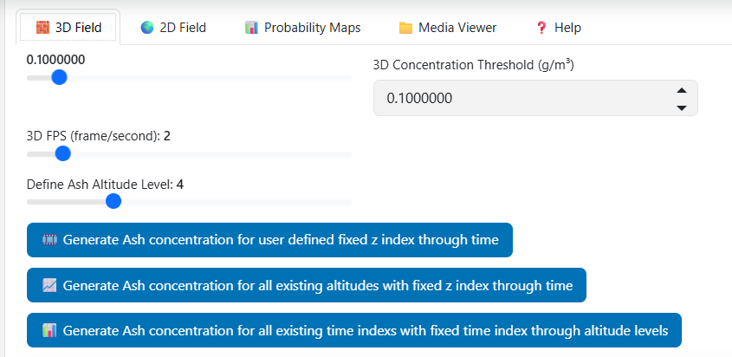
Figure 3. screenshot of 3D field data processing
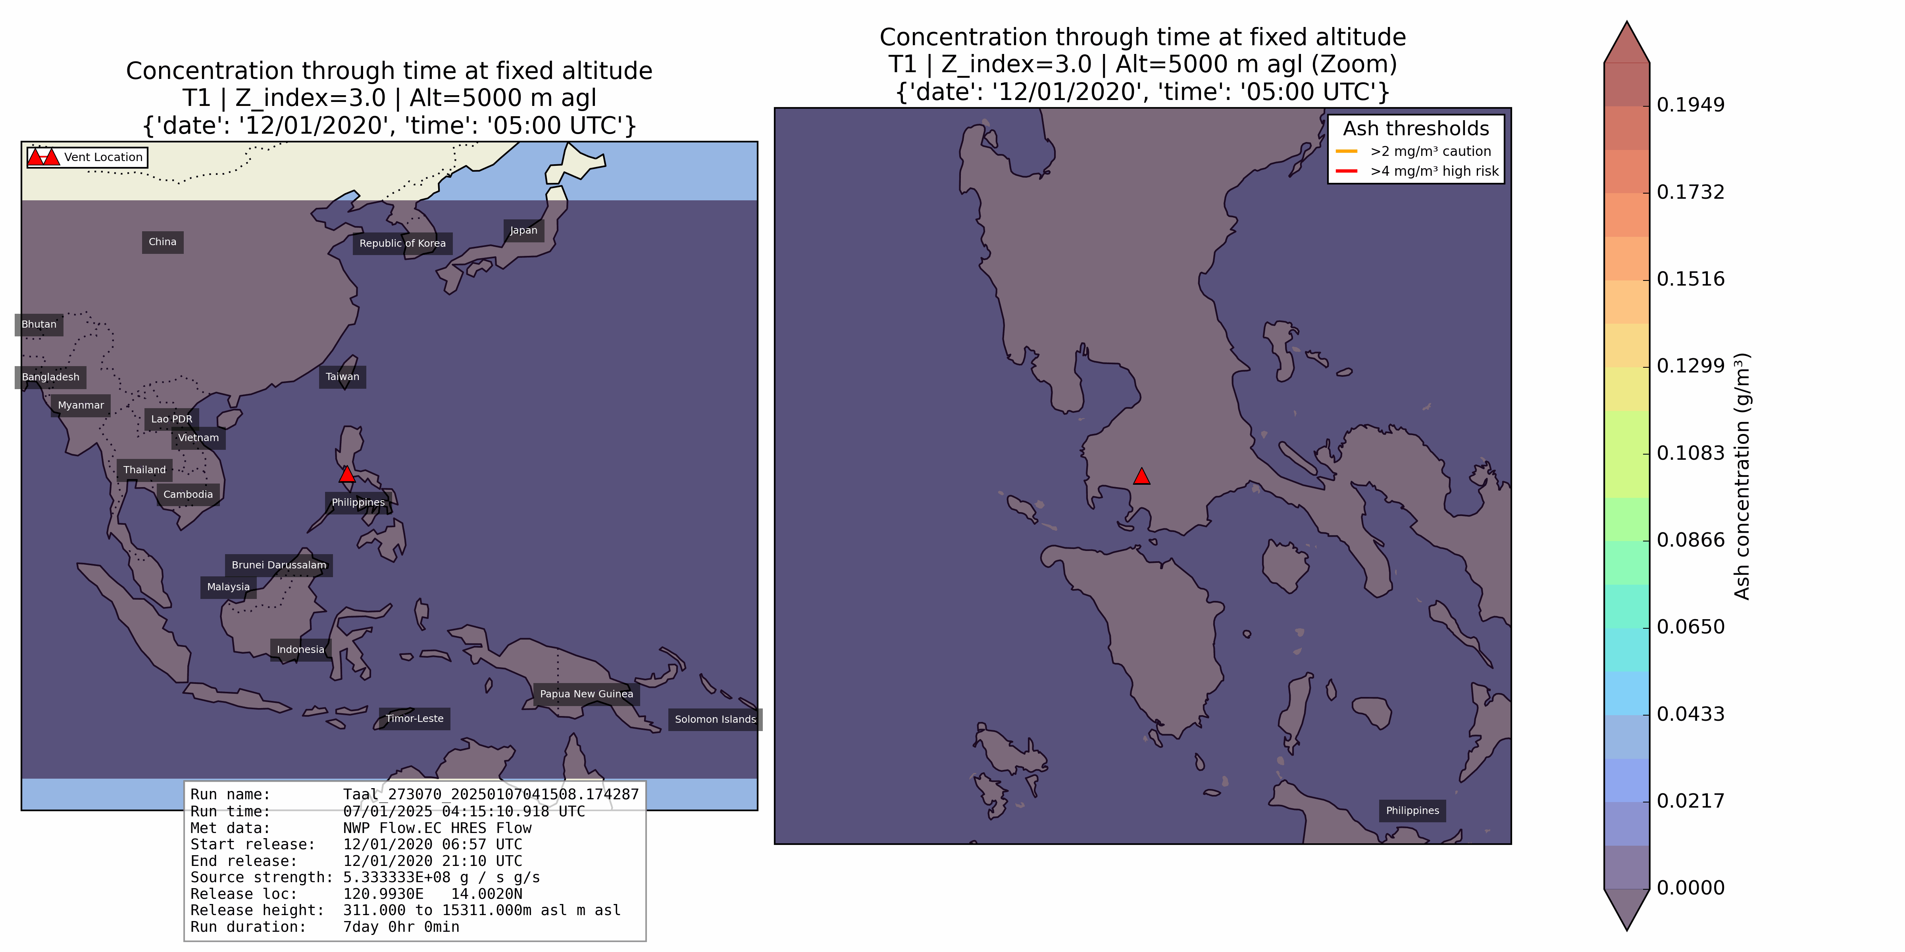
Figure 4. Example of 3D Field Data Processing ash concentration animation for 2020 Taal Volcano. Note: To see full animation please refer to the word document version of visit the GITHUB page link provided at the first page of this document.

2D Field Data Processing Tab
The 2D Field tab provides tools to visualize and animate surface-level outputs from the NAME volcanic ash dispersion model. These outputs include spatially distributed values such as airborne ash concentration, dry deposition rate, and wet deposition rate at ground level. The interface is designed to be intuitive and interactive, supporting thresholding, playback customization, and multiple output types.
Key Components:
- 2D Threshold Slider
This slider allows users to set a threshold value for visualization. Regions exceeding this threshold will be emphasized in the output animations, aiding in the identification of areas with significant ash concentration or deposition. The current threshold value is displayed numerically (e.g., 0.0050).
- 2D FPS (Frames Per Second) Slider
This control adjusts the playback speed of animations, allowing users to fine-tune how quickly each frame is displayed. For example, setting the FPS to 2 will display two frames per second during playback.
Animation Options:
- Animate Air Concentration
Generates a time-based animation of ash concentration in the atmosphere at the surface level. This visualization is critical for assessing low-level air quality impacts in affected regions.
- Animate Dry Deposition Rate
Produces an animation showing the dry deposition of ash particles onto the surface over time. This is essential for understanding ground contamination patterns without the influence of precipitation.
- Animate Wet Deposition Rate
Creates an animation of wet deposition (i.e., ash particles removed from the atmosphere via precipitation). This mode is particularly useful for studying ash accumulation in areas with rainfall during or after an eruption.
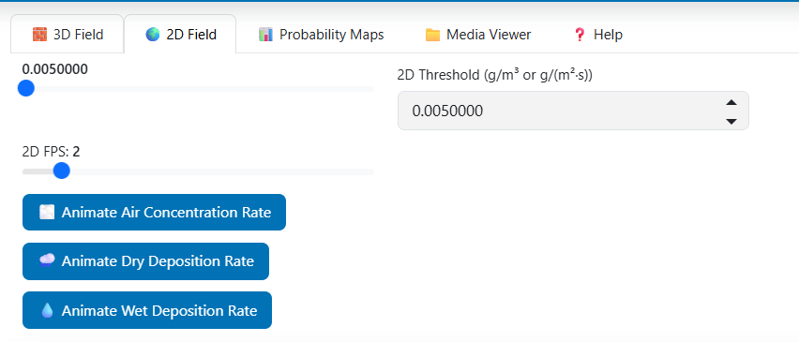
Figure 5. Screenshot of 2D Field Data Processing Tab

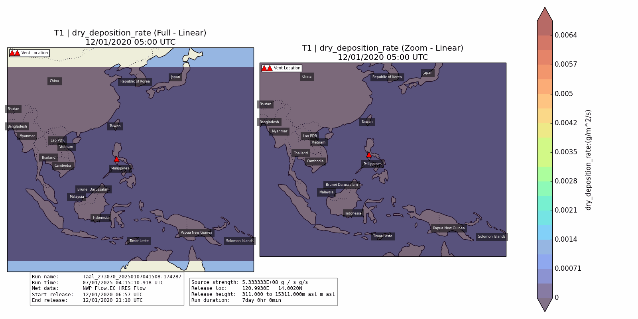
Figure 6. Example of 2D Field Data Processing dry ash deposition rate animation for 2020 Taal Volcano. Note: To see full animation please refer to the word document version of visit the GITHUB page link provided at the first page of this document.
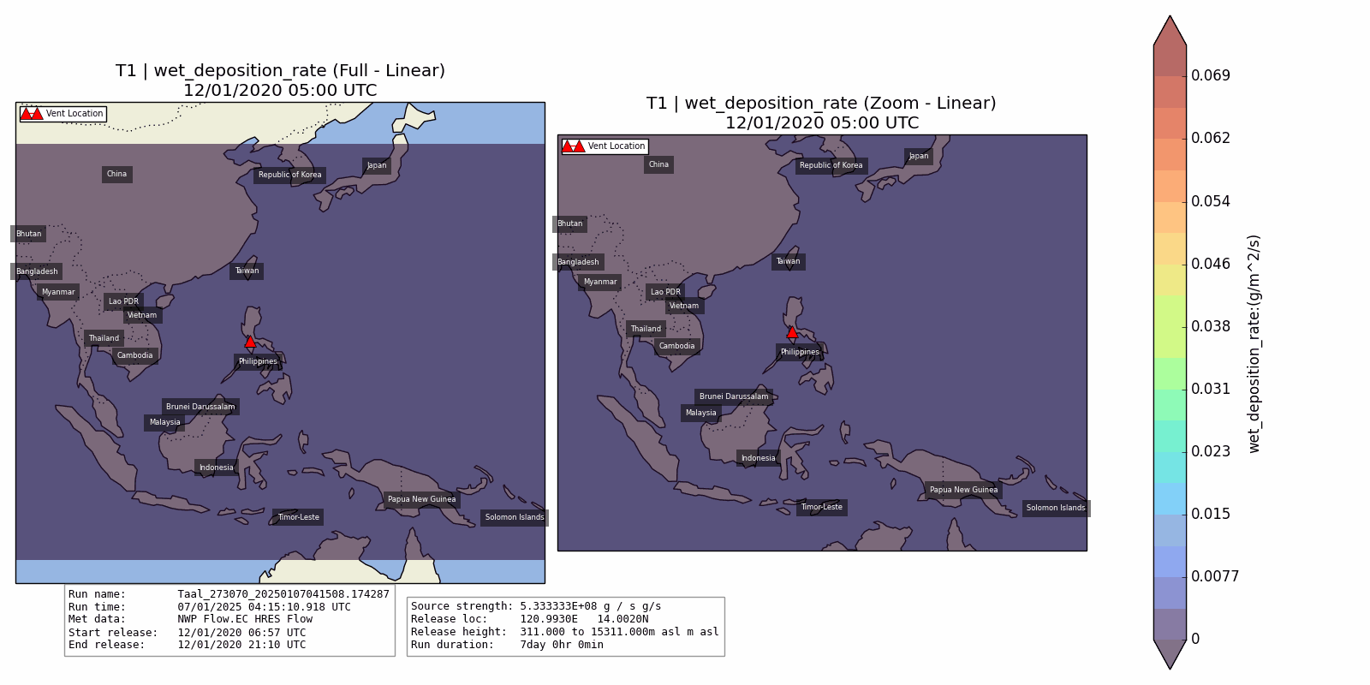
Figure 7. Example of 2D Field Data Processing wet ash deposition rate animation for 2020 Taal Volcano. Note: To see full animation please refer to the word document version of visit the GITHUB page link provided at the first page of this document.

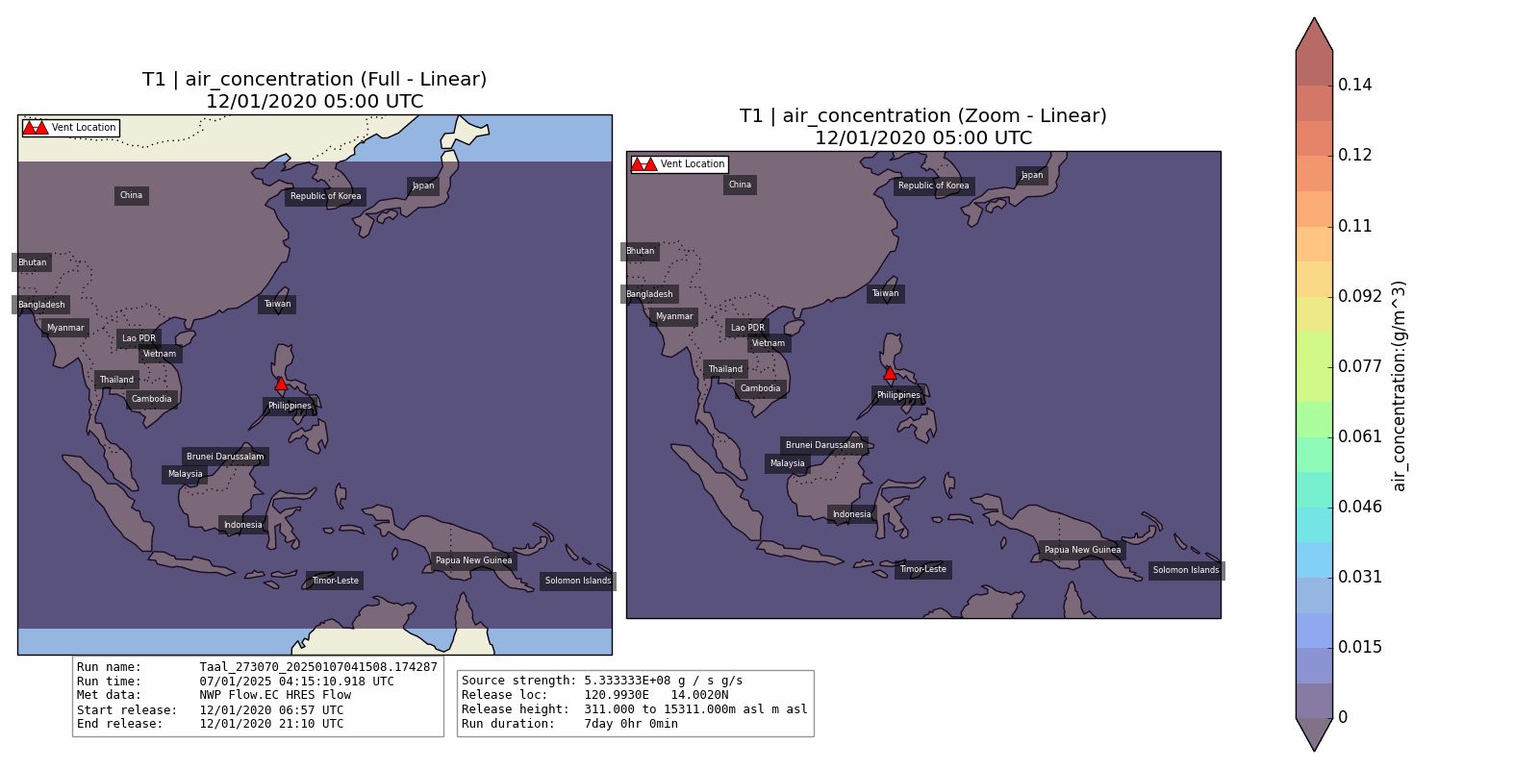
Figure 8. Example of 2D Field Data Processing ash concentration on the surface for 2020 Taal Volcano. Note: To see full animation please refer to the word document version of visit the GITHUB page link provided at the first page of this document.

Probability Analysis Tab
The Probability Analysis tab enables users to assess the probability that simulated ash concentration values exceed a defined threshold both in the atmosphere (3D fields) and at the surface (2D fields).
🔷 3D Probability Section
In the top panel, users are presented with a slider and numeric input field labeled “3D Probability Threshold (g/m³).” This threshold defines the minimum ash concentration of interest—values above this threshold are counted when estimating the probability that a given region experiences significant ash loading. In this case, the threshold is set to 0.0020000 g/m³.
After defining the threshold, users can click the “📍 3D Probability Animation” button. This triggers a calculation across all simulation runs, identifying how frequently ash concentrations exceed the specified threshold at each altitude and time step. The result is a probabilistic volume field that is rendered into a set of spatial maps or animations. This output is particularly useful for aviation hazard assessments and upper-air ash monitoring.
🔷 2D Probability Section
- The lower panel focuses on ground-level and surface processes, such as air concentration
- near the surface and ash deposition rates. The interface again provides a threshold slider, here labeled “2D Probability Threshold (g/m³ or g/(m²·s))”. The current threshold is set to 0.0000100.
- 2D: Air Concentration
Computes and displays exceedance probability maps for surface-level airborne ash concentrations.
- 2D: Dry Deposition
Analyzes the exceedance probability for ash particles settling directly on the ground without precipitation.
- 2D: Wet Deposition
Calculates the probability that ash particles are removed from the atmosphere through rainfall and deposited at the surface.
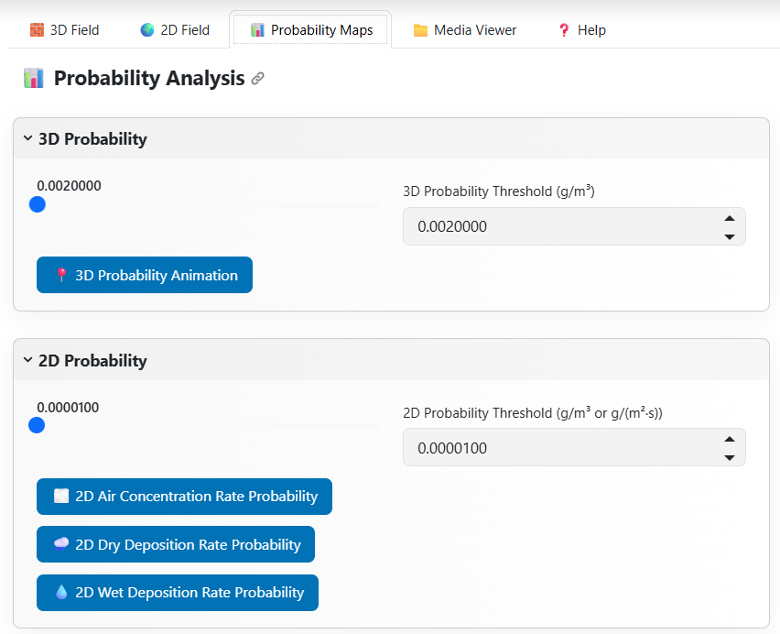
Figure 9. Screenshot show elements of Bayesian Probability Analysis Tab

Media Viewer Tab
The Media Viewer tab serves as a centralized interface for browsing, previewing, and downloading all visual outputs generated by the system—including animated maps, statistical plots, and static frames produced during the ash dispersion modeling and exceedance analysis workflow.
This tab is organized into multiple content categories and supports intuitive interaction with both 2D and 3D data outputs:
📂 2D Outputs
Under the 2D/2d_fields directory, users can view animated GIFs of:
- Airborne Ash Concentration
- Dry Deposition Rate
- Wet Deposition Rate
Each animation provides a full spatial view and a zoomed-in inset centered on the area of maximum deposition or concentration. For example, the selected dry_deposition_rate.gif displays:
- A full regional view on the left panel.
- A zoomed view of the high-impact area on the right.
- A color bar indicating concentration levels (e.g., g/m²/s).
- Key simulation metadata such as release location, source strength, release time, and meteorological data, overlaid at the bottom of the image.
These visualizations are generated from exceedance and threshold-based mapping computations within the 2D Field and Bayesian Probability Analysis tabs.
📂 3D Outputs and Statistical Plots
Additional sub-tabs and folders (e.g., 3D Outputs, Statistical Plots 2D/3D Outputs) will appear if corresponding data products exist. These may include:
- Altitude-specific exceedance maps.
- Probability distributions.
- Vertical ash concentration profiles.
- Predictive interval plots based on Bayesian modeling.

Preview & Playback
Each file is displayed as a thumbnail with a clickable preview button, allowing users to view animations directly within the dashboard before downloading. This helps users quickly assess the relevance and quality of outputs without leaving the application.
⬇️ Download Option
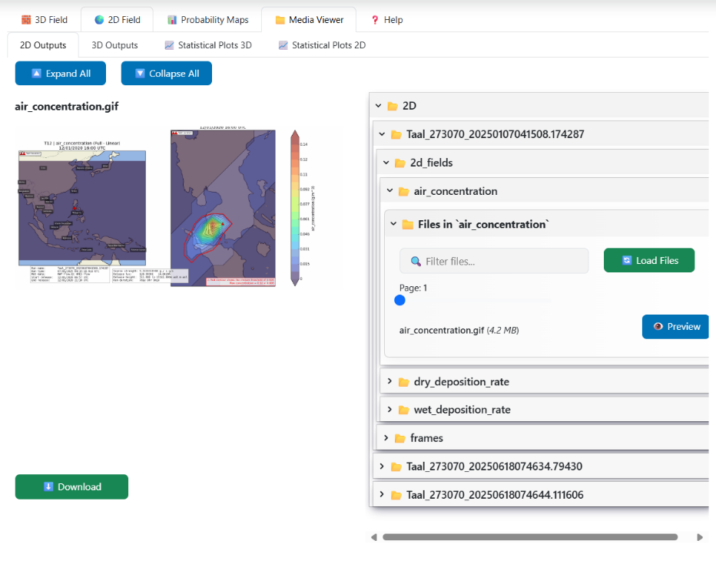
A prominent Download button enables users to retrieve selected visual products in .GIF, .JPG, or .ZIP format for inclusion in reports, publications, or further offline analysis.
Figure 10. Screenshot of Media Viewer Tab
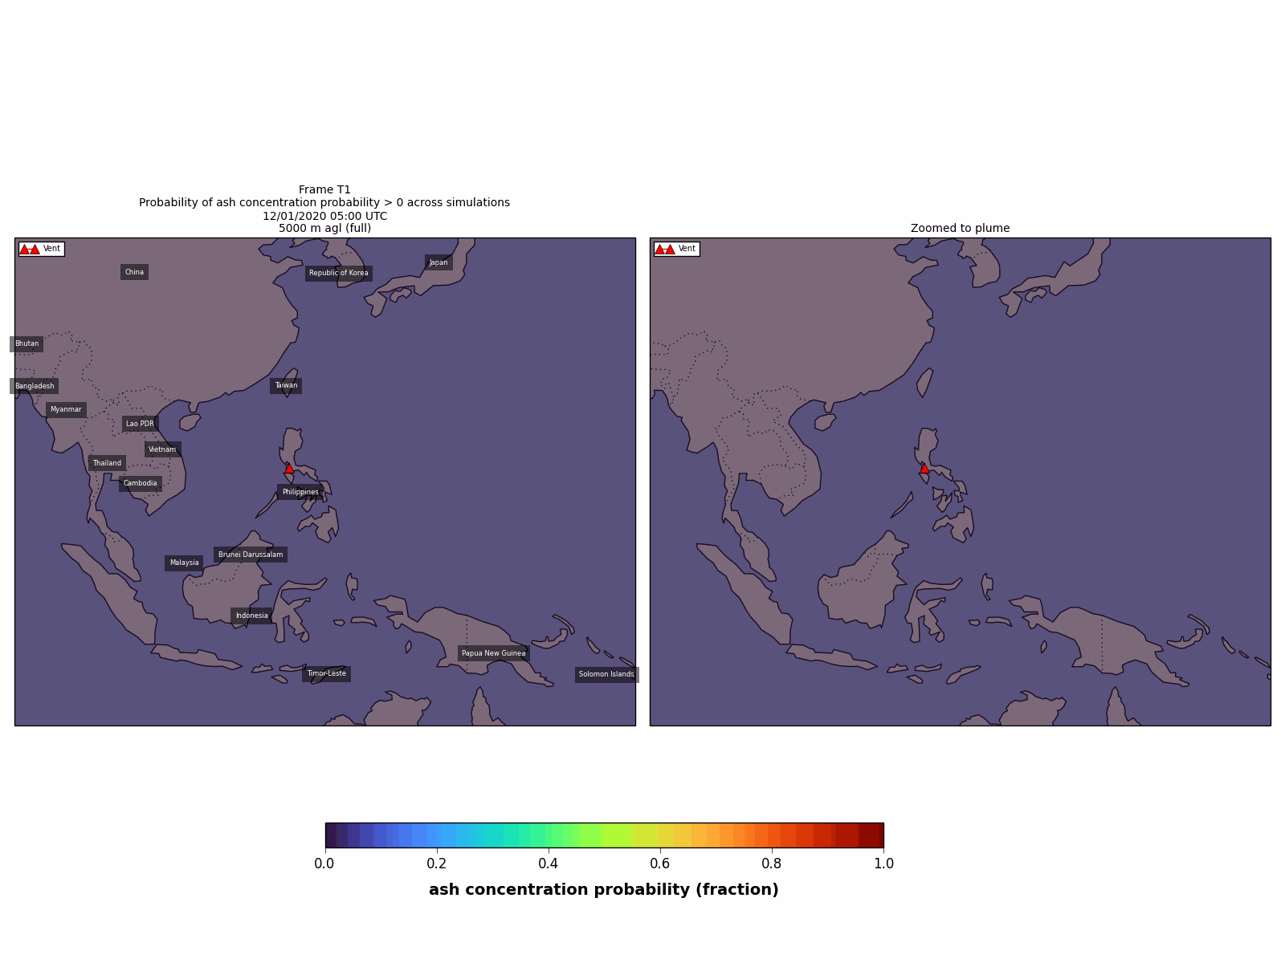
Figure 11. Example of 3D Field ash concentration probability across three simulations of Taal Volcano at altitude of 5km that ash concentration is more than zero.

Training and Documentation:
This private GitHub repository https://github.com/vharg/Eruption-Source-Parameters/tree/main , maintained by Prof. Susanna Jenkins, hosts the complete codebase and documentation for the OSTIn Project, which is structured across three development phases. The repository provides all necessary resources for sampling eruption source parameters, updating them based on observational data, and producing advanced probabilistic visualizations of volcanic ash dispersion using the NAME model.
Each project phase is organized into its own subdirectory (PhaseOne/, PhaseTwo/, and PhaseThree/), with dedicated scripts, data samples, and instructional materials. The root-level README outlines the project's objectives and provides general guidance, while each phase directory includes its own local README or instructions.md to explain specific components.
Additionally, a training session conducted with a student (KONG LI XUAN), to providing hands-on experience with the software.

